Renewable Energy World Magazine, July-Aug 2008, Vol 11, Issue 4

Renewables Are Booming: Is a Bust Inevitable?
by Orlando Wagner and Jochen Hauff

Orlando Wagner and Jochen Hauff compare the booming renewables market with other sectors where a boom has been followed by a bust, on the lookout for danger signals. They conclude that the renewable energy sector has strong foundations - but does have some areas of vulnerability, which they examine in detail. They conclude that industry should 'de-hype' the boom, and that a long-term, harmonized renewables support system is important to stabilize the investment framework and enable investors to fulfill the ambitious political targets in Europe - and elsewhere.

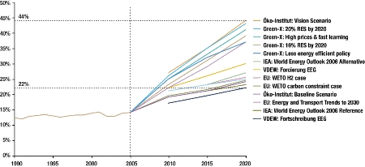
Figure 1. Share of renewables (incl. hydro) in EU-27 electricity generation, 1990–2005 and projections 2006–2020 (%)
Looking at the rapid development of renewable energy capacity installations (excluding large hydro) – with an average annual growth rate of about 14% – and the ambitious projections forecasting a doubling to tripling of the renewable energy share in EU power generation within the next 12–15 years (Figure 1), we can clearly speak of a renewable energy boom.
While this boom is discernable both in electricity and heat generation, as well as in the biofuels sector, and is taking place not only in Europe but also other parts of the world, the discussion here is mainly focused on technologies for power generation from renewable energy sources and on the European market. Interdependencies between European and global markets are, however, not ignored.
By now, financial markets and the media have caught on. Stock prices and market capitalization of renewable energy players are rising rapidly, with RENIXX, a global renewables industry index, beating general market growth, as represented by the Dow Jones STOXX 600 Europe (DSJ 600), by a factor of 2.8 at the end of 2007 for the previous five-year period (Figures 2 and 3).

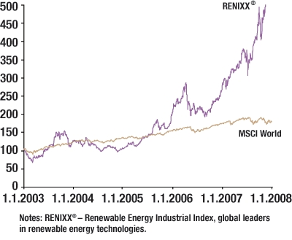
Figure 2. Growth in market valuation of renewable energy companies 2003–2007 Source: IWR
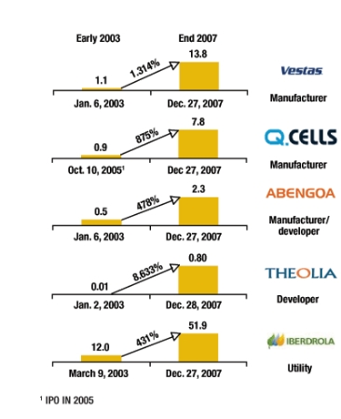
Figure 3. Five-year market capitalization of selected renewables companies (billion €) sources: iwr; morgan stanley, aol borse; dab; boursorama.com; ariva.de; company annual reports
The stock prices of many renewable energy players, representing various technologies and business models, has shot up within the past five years, and resulting market capitalizations of previously small or mid-sized companies now reach well into the billions.
Unsurprisingly, the current renewable energy boom has been receiving a high degree of media attention, reminiscent of the hype surrounding other booms in the not-so-remote past – the internet boom of the 1990s, and the simultaneous telecoms boom being the two most prominent examples. But renewable energy technologies have also experienced booms in the past: the US solar and wind energy booms of the 1980s are examples, albeit on a much smaller scale than the current developments.
The performance of key indices of telecommunications stock in the late 1990s shows a striking resemblance to the current renewable energy boom (Figure 4).
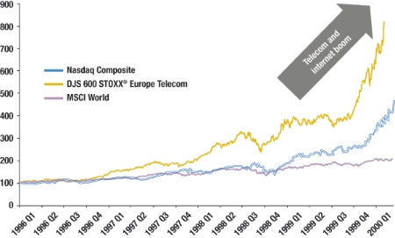
Figure 4. Telecommunications and high-stock indices vs. Dow Jones Stoxx 600 Europe 1996–2000 (2 January 1996 = 100)
In the five-year period before the peak of that boom, the DJS Europe Telecom Index beat the general DJS Europe 600 Index by a factor of 2.8 at the peak. The exact number is a coincidence and strongly depends on the choice of the starting point for the comparison.However, the observation that – compared with the general market – valuations of renewable energy companies have grown by the same order of magnitude as those of telecom companies in the late 1990s warrants at least a closer look at the risk of a bust and the factors that contributed to it in the case of telecom and internet stocks (Figure 5).
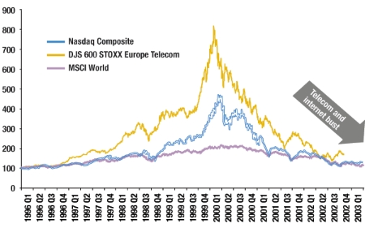
Figure 5. Telecommunications and high-stock indices vs. Dow Jones Stoxx 600 Europe 1996–2002 (2 January 1996 = 100) sources: dow jones stoxx; e.a. couper et al.; “boom and bust in telecommunications”, federal reserve bank of richmond (2003); nasdaq; morgan stanley
But it’s not only past booms in other sectors that can inform the discussion about renewables today. The oil crisis in the late 1970s sparked a renewable energy boom before, most notably in the US.
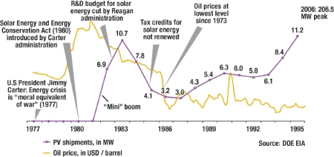
Figure 6. Domestic shipments of photovoltaic cells and modules in the US 1977–1995 (MWp), seen against oil prices (US$/barrel)
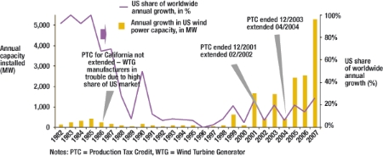
Figure 7. Annual growth in US wind power capacity 1982–2006 (MW) vs US share of worldwide growth (%) sources: doe eere (Annual Report on U.S. wind power, May 2007)
Figures 6 and 7 depict the development of both the brief US solar and wind energy booms back in the early 1980s. A comparison of the installed capacities of the early 1980s with those of today reveals the difference by orders of magnitude. This is largely due to technological progress that has since increased the size of installations and decreased costs. A common factor, however, is the significant dependence on policy decisions that affect capacity addition. Political decision-making with regard to the wind Production Tax Credit has virtually switched the US wind boom on and off at various times in the past. This vulnerability to policy decisions is a key risk factor for a bust in the renewable energy sector today.
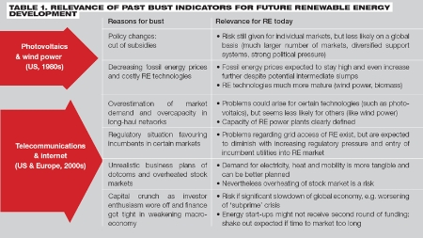
Table 1 sums up the developments and key reasons for the bust of previous booms and attempts a preliminary assessment, in how far the current renewable energy boom is susceptible to these potential pitfalls. It appears that while certain parallels with previous booms and busts certainly exist, the current renewable boom differs in several fundamental ways, which make it less vulnerable to a sudden bust.
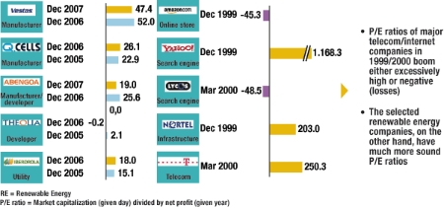
Figure 8. P/E ratios of selected renewable energy companies (2005–2007) vs telecoms/internet companies (1999–2000) sources: company annual reports; iwr; boursorama.com; ariva.de
This can also be seen by comparing the P/E ratios (market capitalization divided by net annual profit) of selected renewable energy companies in the past two years with those of telecommunications and internet players in 1999–2000 just before the dotcom bust (Figure 8). While major telecommunications and internet companies had either negative (due to losses rather than profits) or extremely high P/E ratios, the market capitalizations of renewable energy corporations generally appear to be much more reasonable.
Factors that appear to stabilize the development of renewable energy also include the diverse national systems and technology portfolios, which mitigate risk of policy changes in all markets. Also, the fact that demand for electricity is real and growing is a key difference from the internet and telecommunications booms, which were built in part on anticipated rather than existing demand.
However, parallels to previous busts that should worry renewable energy proponents include the large exposure to policy changes and the reliance on technologies and business plans that are not always mature, nor always assessed soberly – due to the hyped mood of investors and companies’ need for capital.
Signs of doom for the renewable energy boom?
Not all recent news regarding the growth of renewable energy has been good. Sudden drops in growth rates in key markets, increasing competition from other technologies that boast CO2 neutrality and energy security objectives, financial difficulties of key players and stock market price erosion of renewable energy companies, as well as problems with supply bottlenecks and news on difficulties in fulfilling technological and/or environmental performance promises – they do occur.
Recent developments in Germany have highlighted serious setbacks affecting the growth of renewable energy. For example, a drop in the rate of new installation for land-based wind power in the German market, combined with significant delay in offshore development dampened the previously buoyant mood in what was the world’s biggest wind power market in the past decade. At the same time, likely overcapacities in PV manufacturing make investors nervous and, we believe, highlight the dependency of this market on subsidized demand. In all these cases, it is changing or pending policy decisions that directly impact investment in renewable energies and their potential for growth.
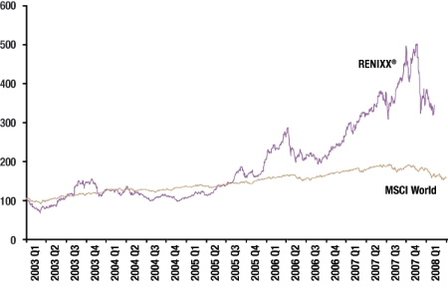
Figure 9. Renewable energy index RENIXX vs Dow Jones Stoxx 600 Europe 2003–2008 sources: iwr (renixx®); morgan stanley
In late 2007 and early 2008, stock markets reacted to these uncertainties and renewable energy stocks took a much stronger blow than the general market (Figure 9). Individual companies lost half or even more than three quarters of their market value compared with their peak of only a few months earlier.
However, we believe this slump to be a market correction rather than the beginning of a bust. The revived climate change discussion in 2007, along with rising energy prices, and pushed by high media attention, saw a significant participation in the stock market by individuals – without in-depth and discriminating assessment of the business plans of individual companies. In view of the rising ‘subprime’ crisis, these smaller speculators often pulled out to capitalize windfall gains, leaving the more long-term-oriented investors. In any case, with only 30 companies in the RENIXX index (compared with 600 in the Dow Jones STOXX), the still low degree of diversification of renewable energy companies, and the limited share of institutional investors, the volatility of such an index is naturally higher than that of a general market index.
Nonetheless, such strong fluctuations can undermine trust in the boom and will deter investors. This could ultimately slow the availability of capital to fund the projected growth.
At the same time, several non-renewable technology options are competing for space – and investment – in achieving the much-cited policy objective triangle of power production at economical prices, significant security of supply, and acceptable levels of environmental impact. Those other technologies are energy efficiency, nuclear, and carbon capture and storage, or CCS.
First, renewable energy faces stiffened competition from investment in energy-efficiency measures, which are gaining increasing policy attention due to often superior performance. Two further policy and technology options are competing directly with renewable energy for power generation investment. The so-called ‘nuclear renaissance’ has received recent media attention after the UK government endorsed it in its new energy policy, but nuclear construction is also under way or under consideration in Finland, China, Iran, France and the United States. Nuclear is in direct competition with large-scale renewable energy applications, such as tidal in the UK and concentrating solar thermal in countries blessed with a sunny climate.
Carbon capture and sequestration is another technology option that is competing for investment funds. While its cost position currently appears unattractive, the prospect of safeguarding established coal-based power production gives strong incentives for large utility players to invest in the further development and prototype deployment of this technology. A narrowing of the cost gap between CCS and carbon increases the chances of its mid-term viability. However, CCS is not likely to be available on a large scale by 2020, thus giving renewables time to penetrate the market and further optimize costs.
Further impediments to the growth of renewable energy are supply bottlenecks, which affect both the availability of biomass fuels and feedstock, as well as – across other technologies – key resources, parts and services for the production and installation of renewable energy power generation technology.
To some degree, supply bottlenecks are a normal side-effect of a boom, as demand expands more quickly than the capacities of suppliers. Under market conditions, this is a self-regulating mechanism, as prices for scarce resources go up, dampening demand. In the case of renewable energy, the price increases are significant, and have partly reversed the effect that economies of scale were expected to have on generation cost. As the demand side is largely determined by support/subsidy levels, however, these price increases have led to a call for increased subsidy levels, which, at least in some cases – such as offshore wind in the UK and Germany – appears to have been successful. Hence, demand is likely to continue to be at a high level, which should, eventually, help to overcome supplier bottlenecks.
Sustained growth for renewable energy
The risk factors pointing towards a ‘bust’, as identified in the previous section, are summed up in Figure 10 and juxtaposed with a set of building blocks for sustained growth of renewable energy. These stabilizing factors are likely to mitigate that risk and support continued growth of renewable energy technologies for power generation.
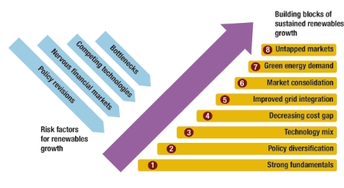
Figure 10. Summary of risk and risk mitigation factors source: own analysis
The fundamental drivers for renewable energy demand are diverse, strong, and long term, and to some extent they partly overlap and amplify one another. They include:
- climate protection policy
- the looming energy supply gap caused by exploding energy demand and restricted resource potential
- growing concern regarding energy nationalism of key suppliers increasing consumer demand for green energy.
These multiple drivers are inevitably going to sustain demand for renewable energy, even if one of them should fail to materialize – which appears unlikely at present.
Furthermore, none of these drivers is restricted to the EU. While it is the EU member countries that currently show the most concern regarding these drivers, and are adopting renewable energy as part of the solution, other global regions and countries are already following suit, or are likely to do so soon. The US market for renewable energy is a case in point, with a mixture of concern regarding energy dependency and climate protection being the main drivers at state level. But even fossil fuels producer countries, such as countries in the Middle East, are becoming increasingly alert to the opportunities that renewable energy options provide. Facing declining oil and gas production and/or increasingly high opportunity costs for burning oil or gas for their own power generation, rather than exporting it at soaring world market prices, the attractiveness of, for example, concentrated solar thermal power generation or wind power is increasing steadily.
As we have seen, it is exposure to regulatory and policy risk that poses the greatest threat to renewable energy growth. This is mitigated, however, by the fact that – unlike in the 1980s or 1990s – a broad range of renewable energy support policies is now available in many countries. Twenty-seven different national support schemes use a mixture of mechanisms – including feed-in tariffs, certificate trading, pure quote trading and investment subsidies. These are unlikely to switch the level of support at the same time or to the same degree, which mitigates to some extent the risk that sudden policy changes can bring. The price, however, is low economic efficiency and high transaction costs for investments. Nevertheless, the market is still dominated by several key countries such as Germany, Spain, the US, and possibly, the UK. Negative signals such as the slump in German growth, the delay in stabilizing the US production tax credit system, and the policy focus on nuclear energy in the UK can not only dampen demand in individual markets, but also function as a potential warning signal to other countries.
The proposed trading system for Guarantees of Origin within the EU-27 would maintain diverse national support systems while at the same time providing the possibility for improving the economic efficiency of investment. This is an important evolution of renewable energy support, because with growing shares of power generation coming from renewable energy technologies, willingness on the part of consumers to pay the costs that are rolled over to them seems likely to deteriorate.
Greater efficiency in allocating investment in Europe is thus urgently needed: while it is good that Germany has strongly supported PV production by creating a domestic market, it is now high time that countries with a much bigger solar resource become the location of large numbers of PV installations, where they can operate at much higher efficiencies.
On the same note, the fact that the available technology portfolio offers a broad range of applications with differing cost and environmental effectiveness provides a further buffer to a possible bust: for while a specific technology might not reach breakthrough in a particular market, the availability of various technologies implies that ‘renewables’ as a whole can grow, even if an individual technology fails to live up to expectations.
Here, too, increased focus on least cost and optimal environmental impact would improve the long-term credibility and public acceptance of payments rolled over to consumers. At first sight, this appears to position PV unattractively. Nevertheless, there are niches, such as in island systems and domestic applications, where PV is an attractive choice. For wider application, such as grid-connected solar parks in Germany, the economic and environmental performance clearly speak against continued support at the levels granted originally. German policy makers appear to share this view and have recently reduced feed-in rates for PV. For investors and companies this signals a need to develop new markets and to think seriously about possible product diversification.
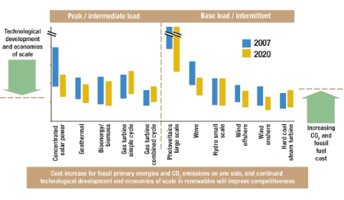
Figure 11. Levelized costs of electricity generation for selected renewables and fossil technologies (new plants) 2007 vs 2020 €/MWh sources: eu: the support of electricity from renewable energy sources, 2008; iea: projected cost of generating electricity, update 2005; royal acadamy of engineering (uk) 2004: the cost of generating electricity; a.t. kearney and own analysis
A crucial stabilizing factor for continuous growth of power generation from renewable energy sources is the decreasing cost gap when compared with conventional technologies, as indicated in Figure 11, above.
This will, in our view, be driven primarily by increasing prices for oil, gas and coal, as well as the cost of CO2 emissions associated with power production from these fuels. At the same time, technological progress and economies of scale will further reduce the cost of renewables, although this cost reduction is dampened by the bottlenecks previously discussed.
Even if the rising raw material prices and supply bottlenecks do lead to higher-cost renewable power generation, the position relative to conventional fuels remains likely to improve. This is based on our assessment that the high level of oil, gas and coal prices is based on structural factors that are likely to last in the long term, while bottlenecks in renewable energy technology supply chains will eventually be overcome. Furthermore, high raw material prices and technology supply bottlenecks are also having an impact on conventional power generation technologies; hence the relative competitive position of renewable energy is unlikely to be affected to any great degree.
A key point of criticism that renewable energy proponents are facing is the burden that intermittent, or variable, means of power production – such as wind and PV – place on the existing power grid infrastructure that was designed and installed for the conventional generation mix. These difficulties are, for the most part, real and not, as is sometimes suggested, mere attempts by established utilities to block the development of renewable energy. At the same time, intelligent ways to overcome these technical difficulties are emerging and these do not always imply time- and cost-intensive grid extensions. Instead, improved forecasting and grid management (including monitoring and planning), as well as system approaches such as the development of virtual power plants (in which a cluster of renewable generators relate to the grid as one unit) offer new, cost-effective ways to decrease intermittency problems considerably and at a reasonable cost.
Such approaches will be employed increasingly often, as established utility companies move strongly in the renewable energy generation market. Given their existing portfolio of conventional power plants and storage facilities, the utilities are well positioned to embed renewable energy generation capacity into their overall portfolio.
The ongoing consolidation among renewable energy systems manufacturers is an inevitable process as the industry matures, and will further increase the efficiency and robustness of players. The consolidation situation of the various renewable branches is very different. While the relatively mature wind power industry has already undergone a number of significant mergers and shows a large degree of technological convergence, the field of biomass technologies is characterized by a large number of small and medium-sized companies and a multitude of technological approaches. Meanwhile, emerging technologies, such as marine energy, are still in the phase when the number of players is likely to increase due to new entrants rather than decrease due to mergers.
Accordingly, the specific drivers of consolidation differ from industry to industry. Common to all technological subsectors, however, is a need to react to the potentially growing volatility of the stock market and associated unease among other sources of finance for growth. Gaining size and diversifying the geographic reach and/or the technological portfolio are possible strategies to mitigating the vulnerability to the risks on a company level. A second important driver for consolidation in several industries is the bottleneck situation in some supply chains. Here, vertical integration along the value chain and close supplier partnerships are the main strategies to secure supply chains and minimize associated risks.
A fundamental growth factor for renewable energy is the increasing demand for green energy products as ‘green consumers’ become mainstream, especially in western Europe. Organically grown food might serve as a relevant example. For a long time, organic food was in demand from a fairly narrow group of consumers willing to pay premium prices in specialized shops. Now, organic food is on offer in many supermarkets and discounters, thus reaching a broader audience willing to pay a certain premium.
In the case of green energy consumers, in Germany ‘post-materialists’ and ‘modern performers’ were among the early adaptors. However, now more traditional and middle class consumers are switching to green energy – hence the market share is bound to increase. The question is, how fast? The number of green energy customers rose from 490,000 in 2004 to an estimated 1 million in 2007. However, the shift from niche towards mainstream was boosted by a public relations disaster of an established market player in relation to nuclear power plants, while other players posted record profits at times of strongly rising consumer electricity prices. This underlines the fact that the growth of green energy is not immune to potential setbacks. It could also be argued that the large share of renewable energy generation supported by mandatory mechanisms can crowd out unsubsidized green energy demand, discouraging consumer choice in favour of green energy.
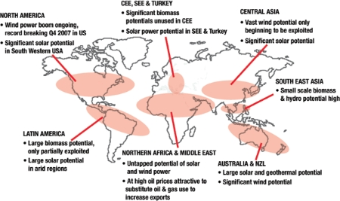
Figure 12. Untapped market potentials for renewables in different world regions Source: A.T. Kearney analysis
While the lion’s share of renewable energy growth (excluding large hydro) has so far been located in Europe, there are very significant, largely untapped markets that can secure further growth (Figure 12). The recent boom in North America is a case in point, and many players direct their growth activities to this large market.
Particularly attractive in the mid-to-long term are Mediterranean and Middle East countries, where strongly rising oil and gas prices increase the cost of not using renewable energy to increase power production. Technologies such as concentrating solar power and wind are particularly interesting for desert regions with low population densities, as direct current grid technologies potentially enable efficient transport to demand centres.
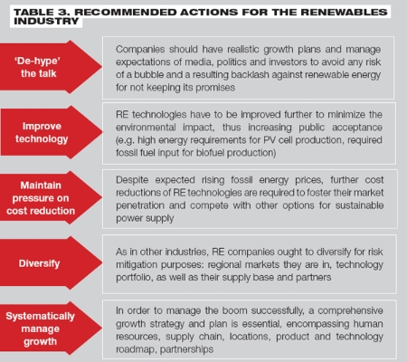
Table 3 spells out our recommendations regarding actions renewable energy companies should take to sustain growth. An important element is to remain credible by ‘de-hyping’ the talk and thus manage the expectations of the public responsibly. At the same time, industry needs to maintain pressure on cost reduction as times of supply bottlenecks and increasing subsidy levels are likely to pass.
Jochen Hauff works with A.T. Kearney, Berlin, Germany; Orlando Wagner, formerly with A.T. Kearney, now works with a global power generation equipment supplier.
e-mail: Jochen.Hauff@ATKearney.com
Acknowledgements
The authors would like to thank Michael Stiegler of the University Erlangen-Nürnberg, Germany, for his support regarding the various company analyses as well as Dr Norbert Allnoch and Bernd Kleinmanns of the ‘Internationales Wirtschaftsforum Regenerative Energien’ (IWR) in Münster, Germany, for the insightful discussion on the evolution of the renewable energy index RENIXX®.
Jochen Hauff furthermore wishes to thank his colleagues Wolfgang Haag, Horst Dringenberg and Florian Haslauer at A.T. Kearney for many hours of fruitful discussion surrounding renewable energy sources.
The opinions expressed in this paper, however, remain solely those of the authors.
Image Gallery (15)
