The imperative of controlling vehicle numbers and increasing access: Report on public transport projects in Delhi

In Response to the Hon’ble Supreme Court Order Dated January 23, 2004
(In the matter of W.P.(C) No.13029 of 1985; M.C. Mehta v/s UOI & others)

July 2004

Environment Pollution (Prevention & Control) Authority

for the National Capital Region

1. Background: status of public transport projects in Delhi

On January 23, 2004, the Amicus Curiae for the ongoing public interest litigation on air pollution in the National Capital Region of Delhi had submitted an IA (IA No. 226) to the Hon’ble Supreme Court. This IA brought to focus the rapidly growing number of vehicles that threatened to destroy the gains of pollution control. If not checked with public transport augmentation and travel demand management plans the gains from small improvements in vehicle technology and fuels would be lost. The Amicus presented data to show how growing numbers, crippling congestion and slow traffic were aggravating the haze of pollution.

The IA 226 has taken note of the following affidavits from the Delhi government that have made reference to improving public transport in the city and made comments:

- The affidavit of the government of NCT of Delhi in response to the EPCA report dated May 2, 2003. The state government presented plans to improve the public transport but these plans remained without clear milestones and deadlines.
- The government of the NCT of Delhi in its affidavit dated December 6, 2003 had sought the Court’s directions on purchase of 10 high capacity buses to augment its public transportation schemes. But once again, the government had failed to give to the Court detailed schedule and dates of completion.

IA 226 has sought that the directions be issued to the Delhi government to submit an integrated and cohesive plan to lower the rate of growth of private vehicles, congestion including a plan to augment public transport and the implementation of high capacity bus system in the city. Plan to include firm deadlines and milestones to monitor implementation.

In response to IA No. 226, the Hon’ble Supreme Court on January 23, 2004 served notice to the Delhi government.

2. Plan for public transport submitted by Delhi government

In response to the Hon’ble Court order of January 23, 2004, the Delhi government filed a counter affidavit in March 2004. The counter affidavit detailed the status and the following plan for augmenting public transport as a means to control vehicle numbers in the city:

- Increase number of buses: The Stage Carriage Fleet (city transport) has been augmented to about 7,300 buses on stage carriage routes of which 3,100 are operated by DTC. This is supplemented by 2,700 CNG buses on the chartered services and about 4,200 mini buses. In order to improve the efficiency of the bus system, efforts have been made to ply these on the basis of Unified Time Table (UTT) and rationalisation of routes.

- High Capacity Bus System (HCBS) and Electric trolley Buses (ETB): An Expert Committee constituted under the chairpersonship of the Chief Secretary had submitted a report on ‘Sustainable Transport System” in Delhi in which plans for implementation of two mass transportation systems, namely, High Capacity Bus System (HCBS) and Electric Trolley Bus System (ETB) was recommended. The Delhi government is in the process of establishing the infrastructure for HCBS, ETB and light rail transit (LRT) (in the walled city). The counter affidavit gives the timetable for the implementation of these systems.

- Corridors were identified as follows:

High Capacity Bus corridors (total 98 km)
- Nangloi – Peeragarhi – Punjabi Bagh – Anand Parbat – Rani Jhansi Road – Link Road – Gole Market – Shivaji Terminal (20 km)
- Azadpur – Wazirpur Industrial Area – Punjabi Bagh – Raja Garden – Naraina Vihar – Dhaula Kuan – Moti Bagh – South Extension – Mool Chand – LSR – Nehru Place (32 km)
- Jahangirpuri – Azadpur – Rana Pratap Bagh – Malka Ganj – St. Stephens’s Hospital – Mori Gate – Old Delhi Railway Station (12 km)
- Dr. Ambedkar Nagar – Masjid Moth – Mool Chand – Sunder Nagar – Appu Ghar – Delhi Gate – Lal Qilla – ISBT (19 km)
- Anand Vihar – Karkarduma Chowk – Swasthya Vihar – Lakshmi Nagar – ITO – Bara Khamba Road – Shivaji Terminal (15 km)

Electric Trolley Bus corridors (total 32 km)
- Hari Nagar Clock Tower, Lajwanti Garden – Kirby Place, Dhaula Kuan – SP Marg – Willingdon Crescent – Talkotora Stadium – Central Sectt. (16 km)
- Badarpur – Sarita Vihar – Ashram Chowk – Humayun’s Tomb – Sunder Nagar - Pragati Maidan (16 km)

- Delhi Metro Rail Project has been planned for 245 km. Phase I of this project is being implemented through the Delhi Metro Rail Corporation (DMRC). These consists three lines – Shahdara – Trinagar – Rithala (line no. 1), Vishwa Vidyalaya – Central Sectt. (line no. 2) and Barakhamba Road – Connaught Place – Dwarka (line no. 3).

- Modernised luxurious CNG buses: The Transport Department has taken a policy decision that only modernised luxurious CNG buses will be allowed in the city for which the government is prepared to consider higher fares.

- Integrated Rail Cum Bus Transit System (IRBT): It has been proposed to establish Integrated Rail Cum Bus Transit System (IRBT) in the NCR towns of Delhi in associations with the central government. It will initially have three corridors linking Ghaziabad, Sahibabad and Gurgaon to Delhi.

Delhi government has submitted the following timeline for the implementation of the public transport projects:

Measures | Time Frame
- Operational HCBS corridor – 6 km (Dr. Ambedkar Nagar to Mool Chand)  - Procurement of six HCBS buses | December 2004
- HCBS corridor operational – 19 km (between Dr. Ambedkar Nagar to ISBT)  - Procurement of 20 high capacity low floor (HCLF) buses  - Completion of feasibility studies are 152 km | December 2005
- HCBS corridor – 40 km  - ETB – 16 km | December 2006
- HCBS corridor – 80 km | December 2007
- HCBS corridor – 100 km  - ETB – 32 km  - LRT – 20 km | December 2008

First phase of metro project to be completed by 2005

 | Length (km) | No. of stations
Line no. 1: Shahdara – Trinagar – Rithala | 21 | 18
Line no. 2: Vishwa Vidyalaya – Central Sectt. | 11 | 10
Line no. 3: Barakhamba Road – Connaught Place – Dwarka | 23 | 22
Total | 55 | 50

Map of the proposed corridors planned for High Capacity Bus System and Electric Trolley Bus System

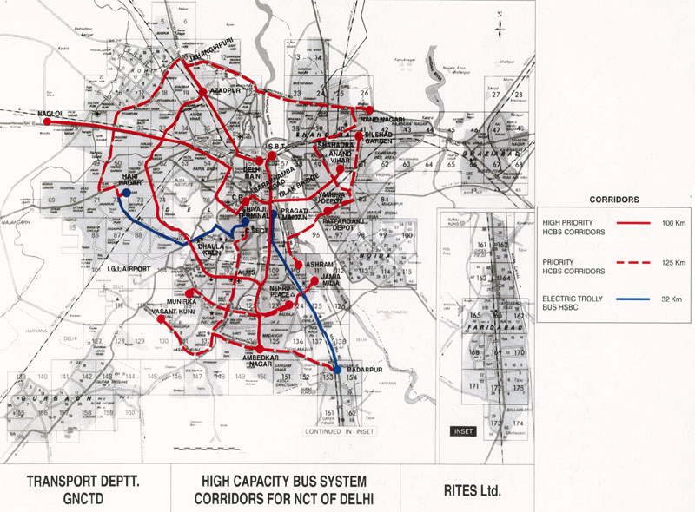

Metro network in Delhi
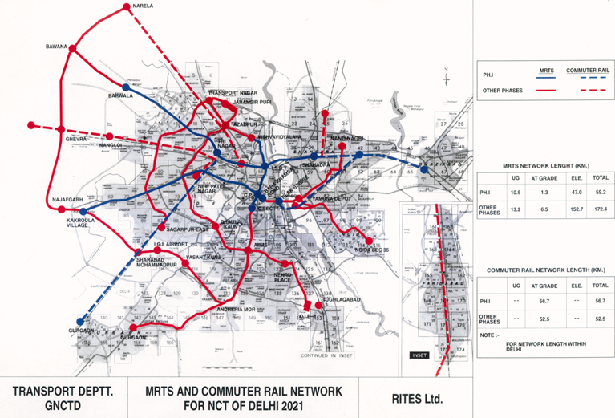

3. EPCA’s observations and recommendations

EPCA shares the concern over rapid motorisation resulting in crippling congestion and haze of pollution that are threatening to undo all gains from the implementation of the wide gamut of the Supreme Court orders in Delhi. Delhi already has more than 4 million registered vehicles and is adding more than 200,000 vehicles every year. More than two-thirds of the vehicle fleet in Delhi is made up of two-wheelers and passenger cars.

Source: Data computed from the Transport department, Government of NCT of Delhi as on March 31, 2004.

EPCA is of the view that the augmentation of the public transport should be accorded the highest priority to enable travel demand management policies that are needed to control the number of vehicles on roads. Delhi government has already developed a transport plan. EPCA commends this effort, as this is an essential element of pollution control programmes in the city.

EPCA organised consultation with the Transport Department of Delhi to discuss the proposals of the public transport projects and the implementation schedule that have been proposed in their affidavit to the Hon’ble Court.

It has been decided that the High Capacity Bus System (HCBS) and Electric Trolley Bus System (ETB), the two mass transport systems will be implemented on a priority basis.
EPCA has perused the Report of Committee on Sustainable Transport prepared by the Delhi government. It is estimated that HCBS or dedicated busways are expected to carry nearly 20,000 peak hour peak direction trips. This is a significant improvement upon the carrying capacity of the current conventional bus system which is estimated to be 2000 peak hour peak direction trips. These proposed bus systems are cost effective compared to metro system and can be implemented fast. In the case of electric trolley buses it has been further estimated that the operational and maintenance costs are lower than a comparable CNG urban bus (Rs 37.03 per vehicle kilometer against Rs 41.83 per vehicle kilometer). The report has given the following estimates for setting up of the infrastructure for HCBS and ETB in Delhi.

Estimated cost of high capacity bus system and electric trolley bus system planned for Delhi

Item | Estimates (In Rs)
Cost of bus ways | 2.5 crore per route-km
Cost of Electric Trolley Bus | 2 crore per route-km
Source: Report of the Committee on Sustainable Transport, Government of Delhi, 2002

The report has given the details of comparative performance of different modes of public transport systems in terms of their passenger carrying capacity, speed, and costs as reported from similar programmes in other developing countries.

Criteria | Dedicated busways | Light Railway | Metro
Passenger carrying capacity (Peak Hour Peak Direction Trips in thousand) | 10-25 | 2 to 20 | 10-80
Speed (Kilometer per hour) | 18-26 | 19-29 | 29-36
Capital costs per route kilometre (In Rs) | 9 – 45 crore | 45-135 crore | 180-405 crore
Operating cost (Rs per passenger km) | 3.6 – 5.4 | 5.4 – 6.75 | 6.75 – 10.35
Source: Report of the Committee on Sustainable Transport, Government of Delhi, 2002

EPCA however is not in agreement with the deadlines proposed by the Delhi government for the implementation of the HCBS and ETB. This proposed deadline of December 2008 should be tightened further for these projects to make an appreciable impact in the short to medium term. It has been decided that the entire project will be implemented by April 2007.

EPCA has further noted that the Delhi government has not yet submitted the details of the second phase of metro rail. This may be made available to the Hon’ble court immediately.

On the basis of the discussion it has been mutually agreed that the deadlines of the proposed plan will be tightened further.

4. Revised deadlines for implementation of proposed public transportation plan

On the basis of the review of the various public transport projects planned by the Delhi government and discussions held with the Transport Department, NCT Delhi, EPCA recommends the following:

- Implement all the corridors planned -- five corridors of High capacity Bus System (total length of 98 km) and two corridors of Electric Trolley Bus System (32 km totally) by April 2007.

- The Delhi government would accordingly submit a detailed plan for implementation of the HCBS and ETB indicating the milestones that will enable proper monitoring of the progress to EPCA.

- Delhi government will submit a status report on the progress of implementation to the EPCA every two months. And EPCA will submit a report on the same to the Hon’ble Supreme Court every six months.

- Delhi government to submit a detailed plan of phase II of the metro with deadlines to the Hon’ble Supreme Court.

