PSInSAR analysis monitors Lake Sarez displacement


Fabrizio Novali
Andrea Tamburini
Brian Young
Patrice Droz
Alfio Fumagalli
Thanks to the availability of satellite data archives covering more than a decade, Permanent Scatterer SAR Interferometry (PSInSAR) nowadays represents one of the most powerful techniques capable of retrieving surface displacements of either natural (rock outcrops) or man made objects (buildings, infrastructures) already present within the surveyed area, acting as permanent radar reflectors.
This paper describes the main features of PSInSARTM technique and the results of an application carried out on the Lake Sarez site.
Lake Sarez (Tajikistan) was formed in 1911 when a massive earthquake-triggered landslide buried the village of Usoy under a 650 m high obstruction which dammed the Murghab River. The resulting 60 km long lake containing over 17 km of water is located behind the Usoy landslide dam in the Pamir range, the highest dam in the world.
Internal strategies to mitigate the risk of failure of the Usoy dam were developed by the UN/ISDR (2000) mission. A global risk analysis of the situation helped, first, in identifying the hazard phenomena related to Sarez that could endanger the population living downstream and, second, at defining a monitoring and an early warning system. Studies have been mainly focussed on:
• the stability of the landslide dam (Usoy dam);
• the extent and evolution of a huge landslide located on the right slope of the lake, about 4 km upstream of the landslide dam.
PSInSAR was successfully applied in studying the evolution of the landslide on the right slope of the lake from 2003 to 2006, providing useful data to assess the activity of the slope and design a conventional monitoring network for a real time surveillance of the unstable area.
LAKE SAREZ CASE STUDY
Usoy landslide dam cross section has an overall upstream slope of 1:3 and a downstream slope of 1:7. The internal composition of the dam remains unknown. The seepage through the dam is under control, in order to prevent a possible lake level rise with consequent overtopping and erosion of the landslide dam.
So far, the lake level has only slightly increased over the years. The average annual inflows match the corresponding outflows from seepage springs, located on the downstream face of the dam. Their total discharge varies between 35 and 85 m /s.
Some 4 km upstream of the Usoy dam, a large unstable slope has been identified and is referred to as the Right Bank Slope (RBS).
Should it collapse into the lake, this unstable mass would create waves that could overtop the landslide dam and threaten its stability.Only punctual displacement measurements across opened cracks on the slope have been carried out since the late 1980s by the Geological Institute of Tajikistan. The results indicate movements of approximately 10 cm/year. But the extent of the unstable area was not clearly assessed and the attempts to drill deep cores have been
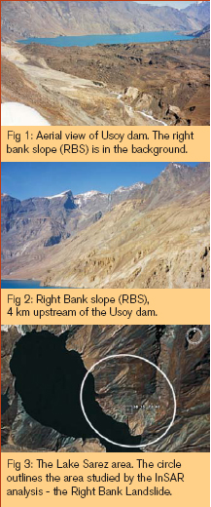
hampered by the extreme difficulty of access and the harsh environment of the region.
INSAR ANALYSIS
Description There are two basic forms of InSAR: Differential InSAR
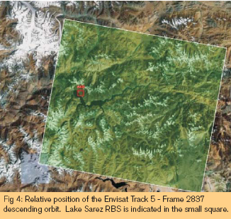
(DInSAR), which measures change from a single interferogram from two radar images, and Permanent Scatterer Interferometry (PSInSAR), a multi-interferogram approach that draws on the changes occurring between a series of radar images. DInSAR is particularly limiting when atmospheric influences are severe and when a continuous history of movement is required.
PSInSAR over comes the atmospheric constraints and is specifically directed at determining movement histories over periods of several years. PSInSAR™ searches the multiple image set for pixels within which are objects that consistently reflect radar signals throughout the entire data set. They are referred to as Permanent Scatterers (PS). This particular technology, in a high-resolution form, was used to process data for this assignment. Radar imagery acquired between 2003 and 2006, by Envisat satellite, presented an opportunity for InSAR to observe motion concurrently with GPS data.
The location of the RBS, representing a surface area of approximately 2 to 3 km , is shown in Figure 3.
Data analysis
The SAR data archive comprised a 23-image catalogued data set, acquired during the satellites' descending orbit, meaning that the platform was travelling from north to south. Each Envisat image covers an area of about 100x100 Km and is identified by the date of acquisition, a Track number - corresponding to the satellite orbit - and a Frame number that specifies the 100x100 Km 'tile' within the Track. In this case, data from Track 5 - Frame 2837 were used, and the frame position is shown in Figure 4. Starting with all the SAR images available, a set of differential interferograms is generated. This entails subtracting the phase of each slave image from the phase of the master image. The master image is selected for its baseline and other properties, in relation to all the other images (the slave images) in the data set. In doing so, the difference in signal path length between each pair of images is calculated.
This difference is related to possible ground motion, but it also contains contributions that might arise from ionospheric and tropospheric effects, as well as possible orbit errors. These additional contributions have to be removed since they can lead to misinterpretations of the phase signal.
Estimation and removal of the atmospheric contribution from the interferometric phase is a key step of the PSInSAR algorithm. Once the signal phase has been corrected for these effects, any remaining changes in it directly reflect ground movement.
Results
Figure 5 shows the estimated average velocity field for the AOI, on the right bank of Lake Sarez. The coloured dots, superimposed on a Landsat background image, correspond to the points where precise differential movement could be meas-
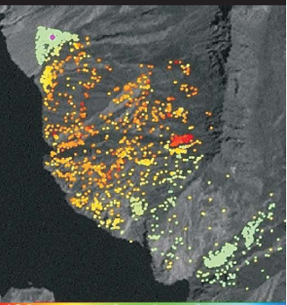
PS velocity map. For the purpose of visualisation the velocity is colour-coded using a spectral scale whereby movement generally ranges from between +20 mm/yr (blue) and -120 mm/yr (red). Some PS may have rates of movement that exceed these limits. The purple circle corresponds to the PS that was used as the reference point for the analysis.

