How can Sustainable Urban Transport contribute to the reduction of GHG emissions
* this article is based on the recent module by GTZ titled "Transport and Climate Change"

Climate Change is currently a major challenge for most nations. Human activities such as excessive burning of fossil fuels, deforestation and waste generation exacerbate this situation.The effects of these actions can be seen in various forms around the globe. Melting of ice caps, raising sea levels, unpredictable rainfall patterns, heat waves are just a few to name. It has been found that future effects will be more frequent in developing countries. Most of these countries rapidly deplete their natural resources and are increasingly imitating the consumptive attitude of the west.

Photo by Manfred Breithaupt
in Hanoi, 2006

Greenhouse gas (GHG) emissions from the transport sector also play an important role in the climate change issue. Carbon dioxide (CO2), a GHG, emissions from the transport sector has risen by the fastest rate in the past three decades. From 1990 to 2004, CO2 emissions from the transport sector alone rose by 36.5%. In developing countries esp. China, India, and other Asian countries the change in lifestyles is driving people to increased automobile usage. This has increased the demand for fossil fuels and automobile oriented infrastructure.
Tackling the problem
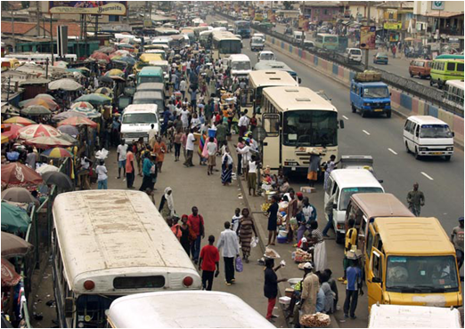
Photo by Allan Quimby (TRL) in Ghana, 2004
Transport is intertwined in nature with social and economic conditions of a city, and is an area that is very difficult to penetrate and solve its emissions problem in isolation. Bypassing old technologies and patterns and fostering innovative methods is the fastest way for developing countries to turn over a new leaf. Three fundamental strategies to reduce GHG's from transport are:
- Avoid (travel by motorised means)
- Shift (to cleaner and environmentally friendly modes) and
- Improve (the efficiency of existing transport systems and technology)
In order to achieve the above-mentioned strategies there are instruments available that fall in the following categories and effectively reduce the greenhouse gases if properly implemented.
a. Planning Instruments: Proper planning can reduce the need to travel and increase accessibility. It can also enable the implementation of new infrastructure such as improved public transit, or newer mass transit options, non-motorised lanes and encourage walking.
E.g.: Integrated land use planning, high density development.
b. Regulatory Instruments: Proper implementation of these instruments would control the existing vehicular population and can avoid the use of old vehicles. These instruments also bring a sense of standard among the automobile users.
E.g.: Standardising the vehicles, Mandatory air pollution tests
c.Fiscal and Economic Instruments: These fiscal and economic instruments can discourage the use of unnecessary vehicle trips and when properly implemented will reduce equity problems in transport users. These instruments could also provide a financial source, for the city government, that could be later used for public transport improvement.
E.g.: Road pricing, congestion charging, parking pricing, fuel pricing.
d. Information Instruments: These set of instruments provide the stakeholders with the available options for them in their city to travel. This will enable the citizens to increase their awareness and hence trigger a shift from their cars.
E.g.: Public awareness campaigns, Travelsmart, public feedback on achievements
e. Technological Instruments: These instruments foster the innovative achievements in technology related to transport. Shifting to cleaner fuels, reducing end-of-pipe emissions and eco-driving fall under this category. In unavoidable cases, using these instruments will enable environmentally safe travelling by motorised transport to a certain extent.
E.g.: Biodiesel, Ethanol, hybrid cars
The majority of the instruments cited above can be implemented with medium-to-low costs, moreover some of the instruments can show immediate fiscal benefits for the city government while some provide intangible benefits in the long run such as reduced air pollution and congestion, increased liveability.
While in some cases there might be a financial need for investment, this need can be sufficed through donors like the World Bank, regional development banks or even through bilateral development cooperation in the form of loans or grants. The implementing agency can also invite the private sector to invest in the case where the investment will benefit the private sector. Mechanisms such as Clean Development Mechanism (CDM) allow international investment in developing countries to offset carbon emissions. Furthermore, institutions such as the Global Environmental Facility (GEF) provides co-funding to projects that aim towards global environmental protection.
GTZ-SUTP's role in mitigating climate change

Mitigating transport problems and hence addressing the climate change issue from the transport sector has been one of the major goals for GTZ-SUTP. As steps to achieve the goals, GTZ-SUTP has developed a series of modules collectively called “Sourcebook” which describes current transport issues. Recently, there have been new modules focussing directly on CDM (titled “Module 5d: The CDM in the Transport Sector”) and Climate Change (titled “Module 5e: Transport and Climate Change). These modules are available for free download from the SUTP website http://www.sutp.org .

Photo by Shreya Gadepalli in Bogota
2004
GTZ-SUTP also provides technical assessment on various sustainable transport topics including BRT planning, Non-motorised transportation, Public awareness, Transport Demand Management, Clean Development Mechanism. To get more information on our activities please visit http://www.sutp.org or http://www.sutp.cn (for users in China) or send an email to sutp[at]sutp.org

