http://carma.org/blog/just-the-facts-on-the-state-of-ntpcs-carma/

Just the Facts: On The State of NTPC’s CARMA

Posted by Kevin Ummel September 3, 2008

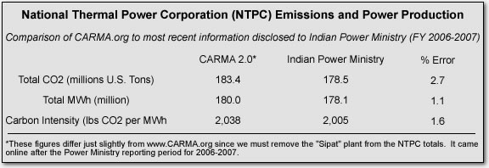

Recent weeks have seen the carbon footprint of the National Thermal Power Corporation - India’s largest power company - come under some scrutiny. A Times of India article in late July first noted NTPC’s global prominence in terms of CO2 emissions, drawing upon a now-outdated version of CGD’s CARMA database of global power sector emissions. Last week, a rebuttal from NTPC and the Indian Ministry of Power claimed that CARMA relied upon “inaccurate generation figures” and argued that the company was one of the world’s most efficient power producers. This weekend, an article syndicated in many Indian newspapers publicized the emissions figures from the just-released CARMA 2.0 database, including the Indian power sector’s #3 global ranking and NTPC’s annual emissions of 186 million U.S. tons of CO2. In the same article, the company responded by saying, “We are among the most efficient producers of power using fossil fuels. NTPC is the second best in the world, emitting only 800 grams of CO2 per kwh of electricity generation.” Here I explain the supposed discrepancies, try to set the record straight regarding NTPC’s present carbon emissions, and take a look at the company’s claims regarding efficiency.

I want to make clear that the numbers discussed here and in the articles referenced above are not from a CGD “report” on India’s carbon emissions. The data in question come from the Carbon Monitoring for Action (CARMA) global database (online at www.carma.org), which provides estimated carbon emissions for power plants and companies in every country - not just India.

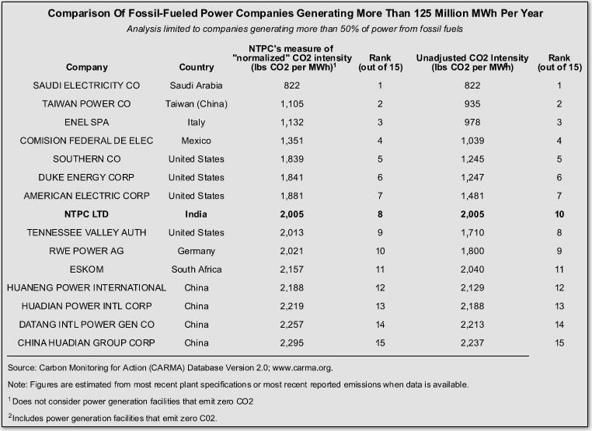

Much of CARMA’s data for Indian power plants comes directly from the Ministry of Power’s own emissions database. As part of an effort to secure funding through the U.N.’s Clean Development Mechanism, the Ministry has disclosed information obtained from companies and plants since late 2006, and we have commended them for doing so. The latest version of that data provides power generation and carbon emissions at the plant level for fiscal year 2006-2007 and is used in CARMA 2.0. So far, we have only matched a portion of the plants in the Indian database to the global one used in CARMA; we hope to complete that matching process for CARMA 3.0. Our policy is to report the most recently disclosed data whenever they are available. In this case, that means we must rely upon data for FY 2006-2007.

CARMA directly incorporates publically disclosed data for 16 of NTPC’s 21 plants operating in FY 2006-2007. For the remaining five plants, CARMA’s statistical model provides estimates. Since, upon closer inspection, the Power Ministry actually reports information for these plants, we are provided with an unexpected opportunity to compare the CARMA estimates to the disclosed numbers. For the five plants in question, the CARMA model overestimated power production by 3.8% and overestimated total emissions by 9.7%. Since these plants make up only 30% of NTPC’s total generating capacity, the overall discrepancy between CARMA’s numbers and NTPC’s disclosed totals for FY 2006-2007 are very low (see table below).

NTPC reports that the company’s power production for FY 2007-2008 was about 200 million MWh. For the purposes of CARMA, however, we can only report figures for 2006-2007; the Power Ministry has not yet released the carbon emissions data for FY 2007-2008. It’s possible to generate an estimate, though, since NTPC has reported a coal requirement of 125 million metric tons. Burning that much coal would release about 196 million U.S. tons of CO2, and NTPC also has a number of gas plants that would add to the total. Since NTPC knows precisely how much fuel their plants are consuming and the specific calorific value of that fuel, they should be able to ascertain the accuracy of that estimate. In any event, we’ll know for sure when the Power Ministry releases new data, probably in December.

I also want to examine NTPC’s claims regarding “efficiency” - in this case, the amount of CO2 emitted per unit of power produced. The assertion made in a number of articles is derived from the company’s own internal analysis, utilizing (old) CARMA 1.0 data that (for Indian plants) relied upon reported emissions and power output for FY 2005-2006. The annual totals for that period, as reported to the Power Ministry by NTPC, were about 165 million MWh and 166 million U.S. tons CO2. The company proceeded to substitute power production for 2007-2008 while retaining the emissions figure from 2005-2006. The resulting carbon intensity (CO2 per unit of power) was then compared to other power companies generating more than 125 million MWh per year after 1) removing from consideration companies relying on fossil fuel for less than 50% of power generation and 2) stripping the remaining companies of any carbon-free power plants. NTPC calls the resulting measure “normalized CO2 intensity.”
NTPC’s pairing of power production from 2007-2008 with emissions data from 2005-2006 resulted in an artificially low carbon intensity. I’ve re-created NTPC’s analysis, correcting for this error and using more recent data from CARMA 2.0. The table below shows the results. I’ve included a column showing “unadjusted” CO2 intensity that doesn’t employ NTPC’s step of stripping companies of their carbon-free facilities (nuclear, hydro, wind, solar, etc.).
NTPC is middle-of-the-pack on either measure. This shouldn’t be surprising given the company’s heavy reliance on coal. The companies ranked higher generally utilize more natural gas (which is significantly cleaner than coal) and/or supercritical combustion technology (which is marginally cleaner than the technology employed in NTPC’s plants to date). NTPC does fare quite well when compared to Chinese power companies.
Finally, we shouldn’t let carbon intensity distract us from the big picture. If we are truly serious about avoiding dangerous and rapid climate change, probabilistic modeling suggests an aggressive 2020 target would aim for a global total of 25 gigatons of CO2. For the sake of argument, let’s imagine a world where developed countries and their enormous emissions disappear overnight. This leaves the developing world with the entire 25 Gton CO2 allowance to “play with.” Recent modeling by the Energy Information Administration suggests that total energy production (all uses, not just electricity) in the developing world will be about 100 billion MWh in 2020. Even if we assume profligate, Northern societies eliminate all emissions in a dozen years, meeting the global emissions target would entail an average carbon intensity across the developing world of about 550 pounds of CO2 per MWh - lower than even the most efficient gas plant can reach today. No efficiency improvement will ever reduce the emissions from coal power to anywhere near this level.
It is quite reasonable to decry the inequity of this reality, and there is no shortage of good arguments to that effect. After all, on a per capita basis, India’s power sector emissions are just 6% of those in the United States and 25% of those in China. These considerations must be central to any global agreement to finance clean technology and combat climate change. But let’s not avoid the truth: No matter how efficiently we burn coal, it can only lead to disaster. And India, perhaps more than any other country, will bear the brunt of climate change.

