GIS Development, Aug 2008

C-GARD: Incorporating rural wisdom

Bhanu Rekha
Associate Editor, GIS Development
bhanu.rekha@GISdevelopment.net

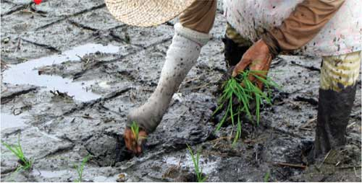
India's second independence of the early 1990s has brought in host of technologies that fuelled the development of the nation on several counts. But the one sector that mostly found itself alienated in this scheme of things is what Gandhiji called the backbone of the country - the village.
The technological and economic advances only widened the urban-rural divide leaving the majority of the population of the country languishing in preindependence conditions. Over the years, several government agencies and a large number of voluntary organisations were involved in developing technologies that cater to the development of rural India. Unfortunately, these technologies hardly touched the lives of rural population. The one technology that has the potential to enrich rural lives and promises to bring in revolutionary changes is - geospatial technology. Understanding this capability, the National Institute of Rural Development (NIRD), with its mandate to channelise and develop policies and programmes for creating social infrastructure for rural development, set up the Centre for Geo-informatics Application in Rural Development (C-GARD) at its Hyderabad centre.
Set up in 2002, C-GARD aims to design and develop geomatics applications for rural development and is engaged in developing the skill and knowledge levels in geomatics technology and tools among the development functionaries from the government, nongovernment, state institutes of rural development (SIRDs), national and international agencies.
"While GIS as a technology factored many things, C-GARD, with its programmes and initiatives, is trying to incorporate the social, ethical and traditional factors into the GIS that are the essential ingredients for creating a fabric of social infrastructure in rural India," says Dr V Madhava Rao Head, CGARD. C-GARD works in association with the Union and State governments and NGOs to facilitate lab-to-land intervention. Here is a peek into the initiatives/ services provided by C-GARD for dissemination of technology in rural areas:

Generation of action plans/detailed project report for watershed development
By extracting contours and drainage layers from topo sheets and integrating them with satellite imageries, various aspects like TIN, DEM, aspect, flow accumulation and sink are generated. Appropriate suggestions are made on this basis regarding the right kind of treatment structures for watershed development. Hydro-geomorphology, soil, land use/land cover etc are also generated from satellite imageries which provide significant inputs for scientific and cost effective watershed development plans. A GIS-based customised software for watershed has been designed with local language interface. This software is in the process of being implemented in eleven states in India.
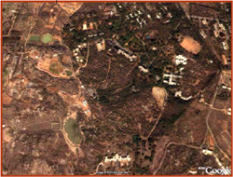
A Google view of NIRD campus at Hyderabad
Comprehensive district development plans
For a given district, the centre has the capability to devise an action oriented implementation plan with the basic input and converging with governmental programmes, economic growth trends, opportunities and gaps. The centre has prepared a GIS-based model district plan for Ranchi by integrating all aspects of resource base and field level database with demographic and infrastructure information.
GIS-based disaster management
C-GARD has developed a GIS-based pilot flood modelling for better community preparedness for the cyclone and flood prone coastal areas of Andhra Pradesh. This model enables the identification of safe areas, routes, corridors, prone areas and also appropriate strategies for better disaster coping and preparedness.
Services at C-GARD | Agro-climatic Planning and Information Bank (APIB)
  • Digital database development
  • Land use and land cover mapping
  • Automatic mapping/facility management
  • Disaster hazard, vulnerability and risk analysis
  • Analysis of multi-layer information
  • Change detection
  • GIS based action plans
  • Decision support system
  • Land information system
  • Regional/district/micro level planning
  • Training and teaching modules
  • GIS based customisation
  • Monitoring/surveillance studies
  • GIS based resource analyses
  • GIS based development atlases
  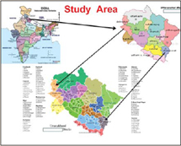
  C-Gard's most successful project till date has been the APIB project which envisages large scale mapping at 1:10,000 scale of two districts - Champawat and Dehradun - of Uttaranchal. The project, the first of its kind in South East Asia, envisages the preparation of agriculture and natural resources inventories of the selected two districts. With 18 layers of well-documented data, APIB claims to cater to all the information needs of the two districts for about 100 years.

Change detection | Village GIS
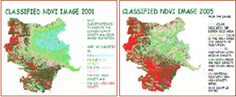  The change detection studies in Attapady Block of Kerala track the temporal changes in vegetation density, vegetation area and other aspects and help in impact assessment of development projects.  This study helped in understanding the causative factors for landscape change and iland degradation in the given area and developed replicable models for participative ec-restortion so that further degradation can be avoided. This system can build on metadata for future studies, planning and decision support activities. | 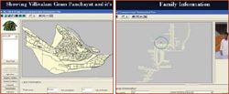  Village GIS developed by NIRD is a customised gram panchayat GIS package of Villivalam village in Kanchipuram district. This package has all analytical features and can handle audio, video, photographs etc with data uploading on the screen. The information base has all point features and cadastre with ownership and household details. This stand alone application can be used as a guide to micro planning. This framework can give the entire socio-political picture of the village and can be applied to village, block, district, state and even for national level decision support system

Preparation of digital databases
On the lines of National Spatial Database Infrastructure (NSDI), C-GARD is preparing digital databases up to block level and efforts are being made to go up to village level selectively. These digital layers are being updated constantly and used in various decision making and planning processes.
Comprehensive development
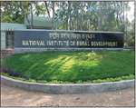
plan of tribal area The centre has prepared a GIS based development plan for the tribal area of Bonai Block in Sundargarh district, Orissa. Critical features like resources base, topography and infrastructure as well as socioeconomic aspect and demographic profile is analysed and GIS based plans for appropriate development thrust are prepared for all round development.
Tribal atlas
The tribal atlas based on the demographic profile of Scheduled - V areas aim at spatial spread and also to understand various aspects of tribal population. This atlas developed by C-GARD is widely used by the organisations working for tribal development. The centre also prepared a development atlas for a district to identify the hotspots for development and to understand the development stage and spectrum within the district.
Training & capacity building
The centre conducts several regional training programmes for development functionaries across the country for developing knowledge base, skill level, scientific temper and use of space based scientific information for effective planning, implementation, monitoring and impact assessment of rural development programmes. Locale specific applications are developed and hand holding is arranged for such training programmes.
C-GARD also provides software and customised solution packages to field level people for ready use. Tutors and manuals guide trained officers to develop and use geo-informatics based information system in day-to-day decision making and implementation of programmes.
REACHING THE UNREACHED
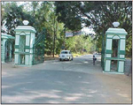
To promote the use of spatial technologies in rural development sector, NIRD has set up four GIS facility centres in Assam, Gujarat, Andhra Pradesh and Orissa. For extensive use of scientific inputs in planning, monitoring, implementation and impact assessment of rural development programmes in the country, the Union Ministry of Rural Development is also contemplating a national GIS centre for integrating all information on watershed and land resources development programmes and other rural development programmes like NREGS.
To make NGOs as proactive partners in rural development, NIRD is setting up a GIS centre at Ralegaon Siddhi in Ahmadnagar area, supporting the vision of Anna Hazare. "GIS is helping C-GARD to bring out the naked issues and provide solutions," comments Dr Rajender R Hermon, Sr Assistant Professor at the Centre.
"Though we don't have a flag to fly, we are happy that we have been working on the most seen but not understood, the unseen and the unprobed issues so far," he adds.
Acting as the 'think tank' of the Ministry of Rural Development and the Ministry of Agriculture, NIRD and C-GARD, through their extensive training schedules, research programmes, consultancy services, knowledge sharing with link institutes and a holistic and humane approach to the issues, are committed to the integrated rural development of the country.

